WELVIEW RESIDENTS ASSOCIATION

MEMBERSHIP
INFORMATION BROCHURE

Dear Welview Resident

Welcome to Welview Residents Association.

Welview RA is made up of approximately 600 houses. This brochure outlines the aims of the association and we trust you will find it informative.

Please do not hesitate to contact us should you have any queries.

Yours in Community

WELVIEW RESIDENTS ASSOCIATION

INTRODUCTION
In July 2007 a serial rapist was running amok in Weltevreden Park, attacking residents, and then an armed robbery took place at a local residence. A small group of concerned and angry residents finally came together and said “enough is enough” it is time to fight back against the criminals in our community and claim back our streets. Meetings were held with the SAPS and Honeydew community police forum and the news was not good. “We, the authorities do not have the resources to effectively protect you in your community, you must protect yourselves”. The most effective way being is to set up a local residents association.

After an initial meeting with local residents it was made clear that we had the support of many, who also wanted to fight crime in our area. By August 2007 the Welview Residents Association was formally established, with the full backing of the SAPS and the Honeydew CPF.

MISSION
The Welview Residents Association is a non-profit organisation with the intent on providing a safe and harmonious environment for all its residents and their visitors. Through working closely with our security company and the SAPS we will ensure that all members are not only secure in their homes but have free and safe passage through the area.

VISION
It is Welview Residents Association’s aim to involve each and every household in our area. Every family and staff member should be involved in active community awareness and together we will strive for a crime free, safe and harmonious neighbourhood.

BORDERS OF WELVIEW RA

Area between Tamarisk, JG Strydom, Jim Fouche, Rinyani and Landhuis.

WHY SHOULD YOU JOIN WELVIEW RA?
- Two Londaloza Patrol cars 2 minutes away from your home
- Extra patrollers into our area to increase visibility
- Direct contact number of the patrol cars
- Discounted Londaloza rate as a Welview member
- Cameras at main entrances (Work in progress)
- Frequent newsletters
- Domestic watch and talks provided to domestic workers
- Member patrols
- Regular street braai’s
- Website - www.welview.co.za
- Facebook group – Welview Residents Association
- Whatsapp Emergency Groups to be notified of any suspicious activity and incidences within our area
- Whatsapp Forum where we chat about… well whatever you would like to chat about
- Clean up of green belt areas – often in conjunction with SAPS and other RA’s
- Working together to report broken street lights, etc to governing bodies

HOW CAN YOU JOIN?
- Be willing to financially contribute towards the Residents Association on a monthly basis. This pays for the patrol vehicle with the armed security officer and the necessary equipment for the residents patrols. There is a monthly fee (payable by debit order). On joining you will receive your starter pack, consisting of:
  - Gate sign for your home
  - Vehicle stickers
  - Security companies contact numbers
  - Other emergency numbers
- Volunteer some of your valuable time towards patrols.
- Provide your contact details to us on the form attached in order to become a member and to receive crime alerts via Whatsapp, e-mail and monthly newsletters.
- Attach this to the debit order form and email to info@welview.co.za.

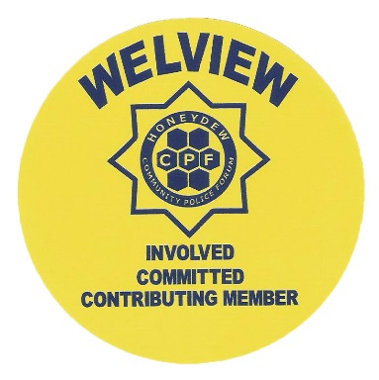
WELVIEW RESIDENTS ASSOCIATION
DEBIT ORDER FORM

I hereby authorise for the Welview Residents Association to debit my account with the amount due. This authority shall remain in force until cancelled in writing. I shall advise the Welview Residents Association of changes to my account details.
Name of Bank
Branch Name of Code
Account Number
Account Type
Start Date
Initials of Accountholder Surname
Amount
Signature of Payer /
Authorised Person

Account Name The Members Welview Residents Association
Bank Nedbank Limited
Brank Cresta
Branch Code 191 30 500
Account Number 1786 022 443
Account Type Cheque

If you are paying by cheque and you have not been given a Welview member number, please use your address a your reference, ex 38 Lobelia

Monthly Fee: R195
Pensioners: R125

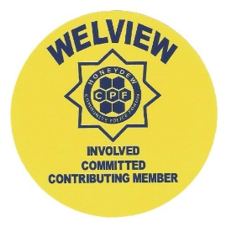

WELVIEW RESIDENTS ASSOCIATION
REGISTRATION FORM

ADDRESS:
Owner / Tenant Details:
- (2)
Surname: | Surname
Name: | Name:
Cell: | Cell:
Bus: | Bus:
Home: | Home:
eMail: | eMail:
Dependant Details:
Name Year of Birth
(1)
(2)
(3)
(4)
Pet Details:
Name Description
(1)
(2)
(3)
(4)
Staff Details:
- (2)
Name: | Name:
Cell: | Cell:
Weekdays Employed: | Weekdays Employed:
Security Company Details:
Linked? YES / NO
Which Company? Emergency No:
Patrolling:
Are you willing to join voluntary Residents Patrol?
YES / NO
Need more details
Whatsapp Groups:
Do you want to be added to the Whatsapp Emergency Group?
Do you want to be added to the Whatsapp Forum Group?
Request to join the Facebook Group online – Welview Residents Association Group
Payment:
Payment amount:
Method of payment:
Options: EFT / Debit Order / Debit order Special to Londoloza Monthly: R195 Pensioner: R125
Emergency Details: (Family member or friend)
- (2)
Name: | Name:
Cell: | Cell:

Complete and send back to info@welview.co.za Date: ___________________

